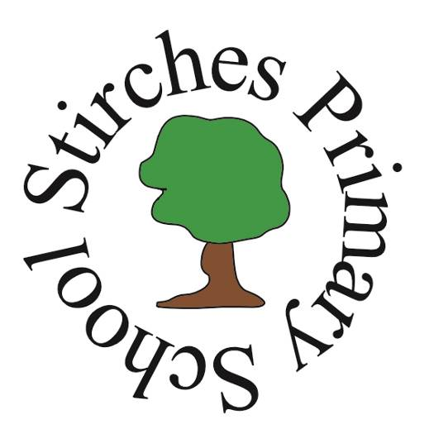

Stirches Primary School

School Information Handbook For Parents/Carers

Roxburghe Drive
Hawick
TD9 7QP

Headteacher: Mrs Lesley Miglis
Tel: (01450) 374389
Email : stirchesps@scotborders.gov.uk

CONTENTS AT A GLANCE

Welcome to Stirches Primary School P3
Staffing P4
The School’s Vision, Aims and Values P5
General Information P6
Attendance and Absence/Safety P7
Our Day P8
Curriculum P9
Health & Wellbeing P10
Pupil Voice P13
Positive Behaviour P14
Partnership with Parents P15
Stirches Parent Council P16
Transitions P16
Child Protection P18
Additional Support Needs P19
The Educational Psychology Service P20
Getting it Right for Every Child - Girfec P20
Medical P21
Emergency School Closures P22
Young Carer’s Act P22
Employment of children P22
Data Protection P22
SBC’s Implementation of British Sign Language Plan P24
Complaints Policy P24
School Holidays P26

This handbook has been written to explain how the school is organised and what services are available. It cannot cover every aspect of school life and may become outdated during the year. Further information can be obtained from the school office. Up to date information is a given through regular SWAY newsletters detailing coming events and school news, or via our School Facebook page: Stirches Primary School.

Welcome to Stirches Primary School

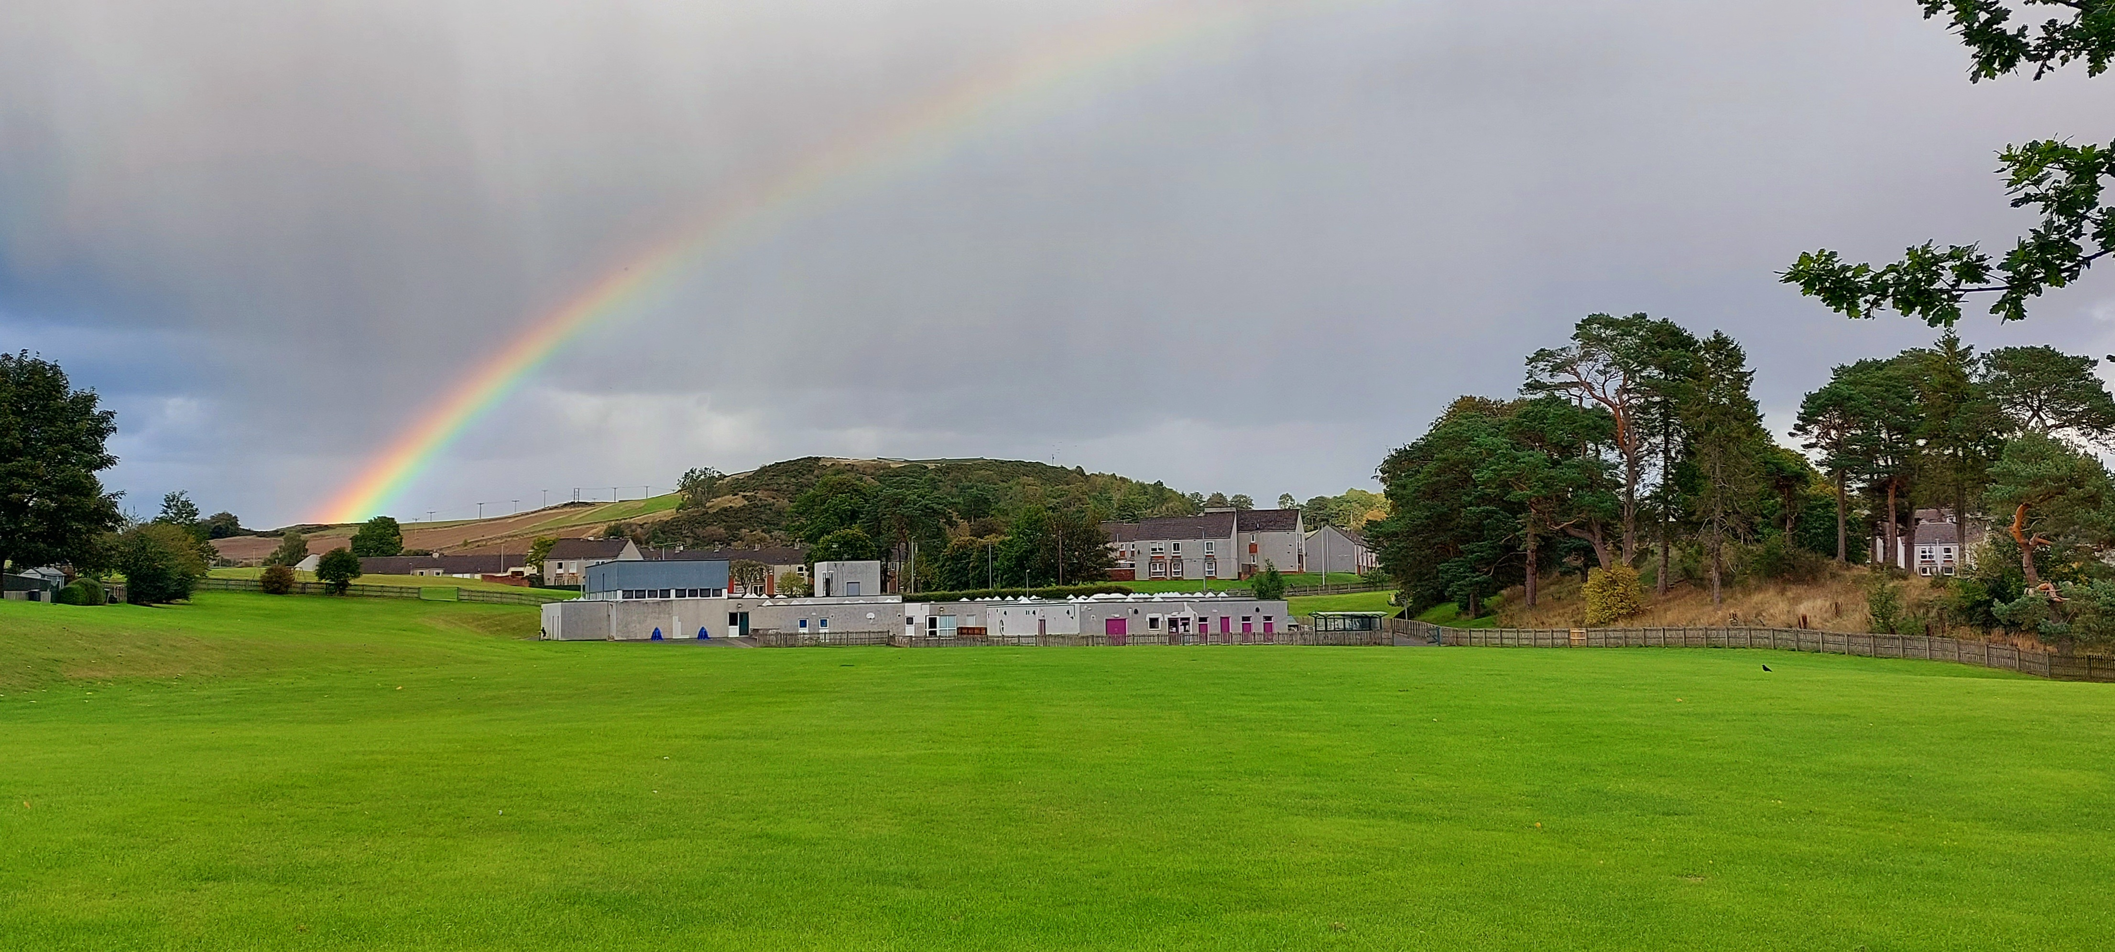

Dear Parents/Carers,

We are delighted to welcome you to Stirches Primary School, as part of our school community and as a partner in your child’s education. We recognise that parents are the key educators of their children and look forward to developing a partnership with you, in order to support your child’s development. This collective approach will promote the learners reaching their full potential.

Stirches Primary School has a very caring and committed staff, who work well together as a team, to ensure the children are motivated to learn through a range of stimulating learning experiences.

Starting school or coming to a new school can be exciting but also worrying. Hopefully this booklet will help reduce the worries and answer many of your questions. Further information can be obtained from the school office. We strive to provide up to date information on upcoming events and school news through regular emails, SWAY newsletters and our Facebook page.

If, you are considering enrolling your child at Stirches Primary School, please get in touch to arrange a visit to the school as this will help you in the decision making process. We constantly strive to make Stirches a friendly school and we are confident that your child will very quickly feel at home here.

At any time, if you have concerns, please feel free to contact the school - we have an open door policy, as good communication is the key to positive relationships with parents and helps promote happy learners.

I look forward to meeting and working with you to ensure that your child’s primary education is both happy and rewarding.

Lesley Miglis
Headteacher
Staffing
Session 2023- 2024

Headteacher Mrs Lesley Miglis
Principal Teacher Ms C Irvine

Class Teachers Mrs C Blacklock/Mrs L Woof P1
Mrs N Kane P2/3
Mrs H Hedley/Mrs K Brydon P3/4
Mr R Wilson/Mrs M Sinclair P5/6
Miss B Hamilton P6/7

Mrs M Sinclair Support for Learning
Curriculum Support Miss E Scott Art/RICCT Cover
Teachers Mr G Thompson PE
Ms C Blacklock RICCT Cover

ELCC (Nursery) Staff Mrs J Sharkey Early Years Officer
Ms K McInulty Early Years Practitioner
Mrs L McGregor Early Years Practitioner
Mrs S Hamilton (P1) Early Years Practitioner
Mrs S Johnston Early Years Practitioner

Non-Teaching Staff Ms A Aitken School Administrator
Mr W Law Janitor
Mrs A Carruthers Additional Needs Assist
Miss E Imray ANA
MS K Blackie ANA
Mrs A Ebert ANA
Mrs A Carruthers Dining Room and
Mrs A Ebert Playground Supervisors

Catering Staff Mrs K Cook
Our School Office Hours
Monday | 8:30 am – 3:15 pm
Tuesday | 8:30 am – 3:15 pm
Wednesday | 8:30 am – 3:15 pm
Thursday | 8:30 am – 3:15 pm
Friday | 8:30 am – 12:30 pm
Our office administrator Amanda Aitken is available at these times to answer many queries. Outwith these times management or the teaching staff may be available to help.

It is very important that the school has accurate contact details for all children so we can contact parents/guardians quickly in an emergency.

Our Vision Values and Aims
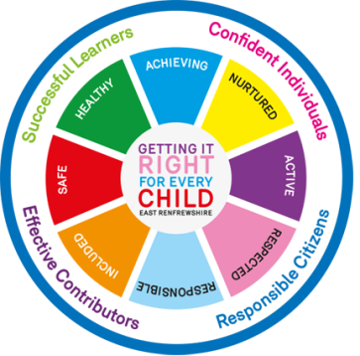
Our Vision, Values and Aims underpin our approach and reflect the SHANARRI wellbeing indicators – Safe, Healthy, Achieving, Nurtured, Active, Responsible, Respected and Included. This ensures that the holistic needs of the child are being considered and that we are Getting it Right for Every Child (GIRFEC).

Vision Statement

“Striving for, Supporting all, Succeeding every day”

At Stirches, our vision is that our children, staff, parents and community work together to create a positive, safe and stimulating learning environment. We provide all our children with high quality learning and teaching experiences to enable them to shine and reach their full potential. We give them opportunities to develop their skills for learning and for life, helping develop the four capacities: successful learner, effective contributor, responsible citizen and confident individual.

Our Values guide the way we work and set the ethos of the school. Together we will…

- Respect
- Encourage
- Achieve
- Care
- Happiness (Promote)

Our Vision is embodied in our school AIMS…

Our Aims

- All pupils will receive a high quality, inclusive education in order to become confident individuals, effective contributors, responsible citizens and successful learners by supporting them in achieving to their highest level across the curriculum.

- In collaboration with our community and stakeholders we will promote quality opportunities for our young people ensuring their individual needs are identified and met.

- Maintain a safe and nurturing environment ensuring wellbeing and thus developing Safe, Healthy, Achieving, Nurtured, Active, Responsible and Respected pupils who are equipped to tackle problems in their life and learning with a growth mind set.

- Successes of our learners are recognised, shared and celebrated.

School Improvement Plan
The school has a Strategic Plan which drives the school forward. This is broken down into a detailed action plan of developments for the coming year.
For session 2023-24 our main aims are to develop our staff as leaders of learning within numeracy through the analysis of data, development of consistent learning and teaching approaches, and the embedding of assessment and moderation. We are also working to consolidate our Assessment is for Learning (AIFL) principles to ensure that children know what they are learning and the steps needed for success. There will be consistent and agreed methodologies to ensure that learners are supported with high quality questioning and that there are opportunities throughout learning to clarify children’s understanding. Embedding our nurturing principles will continue, focusing on transitions and understanding learners developmentally.
At the end of each session a School Improvement Report is written and distributed to parents in September. Both documents are available to parents on request and displayed in the reception area.

General Information
- Stirches Primary School is a non-denominational school that takes children from the Community of Stirches and the surrounding area.
- The school has a nursery class and five primary classes.
- The Current Roll is 106 and 15 in ELC, a total of 121 children.
- After seven years of full-time education, children transfer to Hawick High School - 01450 372429
- A transition programme is in place for ELC to P1and P7 to S1 which includes joint working of staff and visits tailored to children’s needs. Each year staff complete extensive sharing of information between classes to ensure a seamless transition as pupils move through the school.

Transport
Transport is provided by Scottish Borders Council for children who live more than 2 miles from school.

INSET
INSET is part of regular staff development and involves discussion, investigation and implementation of the many and varied aspects of Primary Education. As a result of INSET the staff are able to engage in valuable professional dialogue resulting in curriculum development and moving the school forward. INSET days are held in August, November, February and May.

Organisation of Classes
At the end of school year, parents will be advised of their child’s class and teacher for the following session. It is likely during their time at Stirches Primary that your child will be in a composite class where the same teacher teaches 2 or 3 age groups. All teachers are experienced in dealing with children of all ages and abilities; therefore, their education will not be affected. We follow the SBC Policy on Composite Classes.

School Uniform
At Stirches we wear a school uniform. This promotes a sense of belonging; being part of our school. It also helps identify our children when attending events and trips and helps keep them safe. Our school sweatshirts/cardigans are red or royal blue for P6/7 and display our school logo. Alternatively, they can wear a red/royal blue sweatshirt sourced elsewhere. We also promote the wearing of dark trousers/joggers/skirt with a white polo shirt. ELC children wear red school sweatshirts or they can wear their own clothes. School apparel such as sweatshirts and fleeces etc are available from Elite Embroidery, Unit 3, 8 Liddesdale Road, Hawick. An order form can be supplied. The school tie, costing £8, is available from the school office.

PE KIT - Children should have a pair of shorts, a plain T-shirt and a pair of gym shoes or trainers. The kit should be kept in school as each child receives a minimum of 2 hours of physical exercise per week, and P.E. days can change. We encourage children to keep their gym kit in a gym bag on their peg. It will be sent home at the end of each block for washing unless requested at other times by parents.

Children with pierced ears should wear only sleepers or studs at school for reasons of safety and appearance. Earrings should not be worn. Sleepers or studs must be taped over during P.E. lessons.

Denim wear and team embossed clothing e.g. football shirts, are not permitted in school.

PLEASE ENSURE THAT ALL CLOTHING AND EQUIPMENT IS CLEARLY MARKED WITH CHILD’S NAME.

Attendance and Absence
All schools in Scotland follow National Policy in regards to Attendance and Absence: Children are normally required to attend school every day. Absences should be notified to the school in advance. If your child is going to be absent for whatever reason, please call the school before 9.00am to let us know. There is an answering machine on 24 hours a day so please leave a message and we will pick it up. We always follow up a child’s non arrival at school. Holiday absences during term time are discouraged and except in exceptional circumstances will not be authorised. Good attendance is important in our school. It allows the child to make the most of their education and social development, and gives them better choices in the future. It is your responsibility, in law, as parents, to ensure your child attends school regularly. We actively monitor attendance. If your child attendance drops below 95% we will contact you by letter to alert you to this. We may then begin to actively monitor your child’s absence and contact you at the end of each day of the absence. We do this because we know that your child’s learning will be affected. If your child’s attendance continues to give us concern, then there are a range of routes that we can follow, which will be shared with you. An attendance rate of 90% is equivalent to your child missing a whole year of their education. If you have difficulty getting your child to school, please contact us as soon as possible to discuss how we can support you.

Insurance
Teachers act in loco parentis (in the place of parents) when children are at school. This means that teachers, through their training, undertake to look after the children in their care with every consideration that a parent might be expected to show. Children are not insured directly by the Local Authority. It is the teachers who are
insured for third party liability

SAFETY
Building Security
- In the interests of safety for all concerned, all persons coming to the school must enter by the main entrance and then report to the School Office where they will be requested to sign our visitor’s book.
- In order to ensure the security of all children, adults should bring/collect all ELC, P1 and P2 children to/from the designated door. At the start of the school day, it would be appreciated if you do not wait in the playground with your child.

Road and Playground Safety
We have taken several measures to improve safety around the school.
- Park and Stride is strenuously encouraged. To improve safety outside school, parents are asked to park further away to reduce congestion and improve safety.
- The zigzag lines in front of the school prohibit parking/drop off at any time so that children and drivers can enter and leave safely. DO NOT park or stop to drop your child off here.
- Parents/children should not walk across the staff car park

Video & Photography
The school follows Scottish Borders Council guidance on using Video Recording and Photography within Education. Written consent is required on entry to school to allow the taking of photographs and videos in school. Where parents wish to take photographs/videos at events they should first request permission from the Head Teacher.
Our Day
Monday -Thursday
Morning | 8:45am –12:15pm
Break | 10:30 – 10:45am
Lunch | 12:15 – 1:00pm
Afternoon | 1:00 – 3:15pm
Friday
Morning | 8:45 am –12:30 pm
Brunch | 10:45 – 11:30am
Afternoon | No Session

Breaks
Weather permitting; the children spend breaktime in the playground under the observation of the playground supervisors. Our playground supervisor looks after the children for 15 minutes before the school day begins, during breaks and lunchtimes. Please don’t send your children to school before 8.30am as there will be no supervision. If it is severe weather, please bring/send your child to school so that they arrive just before the bell. The children will have their breaks within their classrooms. We always aim to give children opportunity to be outside, so please ensure that they have appropriate clothing for this.

Tuckshop
Our tuckshop operates daily at breaktime selling ‘Healthy Snacks’. Milk, fruit, cereal and toast are on sale. All items are 20p and children are limited to 2 items.

Lunches
SBC offer nutritious 2 course school lunches; free for P1-5 and £2.40 for P6-7. Four choices are generally available. To order lunches we use an application called ParentPay. Once your child is enrolled at our school, you will receive an activation letter to register with ParentPay, which then enables you to prebook and pay for lunches online. It is parent’s responsibility to book and cancel if your child is absent from school - failure to cancel may result in you being charged for a lunch your child has not taken. If your child does not have a school lunch booked or has not brought a packed lunch from home, the office will phone to ask you to bring a packed lunch in for your child.

Free school meals are provided for those children who are eligible. Forms may be obtained from the SBC website www.scotborders.gov.uk/fsm and returned to Hawick Town Hall. It is the policy of the school to be discreet about the administration of free school meals and children involved are not treated any differently from others who have paid for a school meal.
Children can choose to have a school lunch, packed lunch or a home lunch. At Stirches, all children eat in the school hall. In line with our Food in School Policy, fizzy drinks, nut products and sweets should not form part of a packed lunch. Fresh drinking water is available and children are encouraged to bring a water bottle to school every day

No child who is having a school or packed lunch is allowed to leave the school playground during lunchtime.
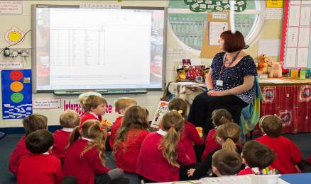

Curriculum
Curriculum for Excellence (CfE) is the education system in Scotland. It includes ELCs, schools, colleges and community learning from 3 to 18 and beyond.

Early Stage – ELCC3, ELCC4 and P1 First Stage - P2-P4 Second Stage - P5-P7

CfE include Experiences and Outcomes across all curriculum areas, up to and including the third level. Some children may work at a level earlier or beyond their age and stage. Throughout all learning, prime importance is given to literacy, numeracy, thinking skills and health and wellbeing.

Aim - The aim of CfE is to raise standards, prepare our children for a future they do not yet know and equip them for jobs of tomorrow in a fast changing world. CfE enables teachers to teach subjects creatively, to work together across the school and outwith, to share best practice and explore learning together. CfE balances the importance of knowledge and skills. Every child is entitled to a broad education, whatever their level and ability, at a pace they can cope with and with challenge they can thrive on.
IDL & Contexts - A range of teaching methods and contexts for learning are used e.g. active, collaborative and enterprising. Learning across the curriculum helps children make links between subjects. Learning outdoors and within the community, gives opportunities for children to apply their learning in real-life contexts.
Educational Visits
School visits to places of interest or events can greatly support the children’s learning. You will be informed of any visits beforehand and details of the arrangements and costs will be given. Costs will be kept to a minimum or subsidised by school funds. A residential experience is offered every year to P7.

Modern Languages - Stirches follows the Scottish 1+2 Languages approach: “Today’s children are growing up in a multilingual world and the ability to communicate effectively in social, academic and commercial settings is crucial if they are to play their full part as global citizens.”
The Scottish Government’s policy, Language Learning in Scotland: A 1+2 Approach, is aimed at ensuring that every child has the opportunity to learn a modern language from P1 onwards. Additionally, each child should have the right to learn a second modern language from P5 onwards.”

Religious and Moral Education
We are a non-denominational school but we are ably supported by a variety of local groups and organisations, including Scripture Union Scotland and Wilton Parish Church who lead religious observation through assemblies and Church services. Through the teaching of RME the children will develop their knowledge and understanding of Christianity and other world religions. Parents who wish to exercise their right to withdraw their child from religious instruction and or religious observance should contact the head teacher to arrange a meeting to discuss alternative arrangements for your child.

Sensitive Aspects of Learning
You will be informed about sensitive aspects of learning such as relationships, sexual health, parenthood and drugs awareness.

Assessment - Progress is assessed in a variety of ways and is integral to the teaching and learning process in order to promote raising attainment and to ensure the learners achieve their potential through support and challenge. Assessment information is used to determine next steps in your child’s learning. Teachers regularly meet with the Headteacher, Principal Teacher/Support for Learning Teacher to discuss the progress of learners. Children are involved in the assessment process through self-assessment which supports setting their own targets.

To find out more about our National Education system follow the links below:
- http://www.educationscotland.gov.uk/parentzone/index.asp
- http://www.educationscotland.gov.uk/
- http://www.skillsdevelopmentscotland.co.uk/

Health & Wellbeing
The Health and Wellbeing of our children and staff is very important to us, we try to
ensure that everyone is happy and leads a healthy lifestyle. Some of the ways we promote good health are:

- Teaching and learning of Health and Wellbeing for all children.
- Building Resilience programme for all children.
- Confident staff, confident children programme for all staff.
- Giving praise/rewards for good work/effort and positive behaviour.
- Sharing successes and achievements at our weekly assemblies.
- Providing chilled, filtered drinking water accessible for all.
- Daily tooth brushing in every class and ELC. (Childsmile)
- Tuck for snacks at morning break run by P7 children.
- Nutritious school lunches and packed lunches that are prepared on the premises.
- Physical Education - every child has 2 hours of PE per week.
- A variety of additional sports with specialists both within school time and after school clubs.

We also work closely in partnership with our health colleagues; the School Nurse, the School Dental Team, the Child Smile Team and the Speech and Language Therapist. We make very effective use of the Glasgow Wellbeing Motivational Profile assessment to monitor our children’s wellbeing and all teachers effectively use this data to create plans to address any health and wellbeing needs.

All pupils at Stirches have access to our Reach Out system where they can contact any staff member and trusted adult confidentially to share any wellbeing concerns (details of this are found in our Respectful Relationships Policy 2023.

Extra-Curricular Activities
Stirches works in close partnership with our Learning Community’s Active Schools Coordinator Paul Scott, with many opportunities for all children to participate. Through this, many taster sessions are made available to the children within the school day. We also have various after school sports clubs. These vary according to the time of year. The children are given opportunities to take part in many wider Learning Community events such tennis, football, cricket, netball tournaments and Hawick Cross Country.

Through Active Schools a wide range of holiday activities are also available. Further information on activities is available from the school office.


Pupil Voice
At Stirches we strongly believe in Pupil Voice; we include our children in decisions which affect them. All children are on a committee. Within class, we promote ‘Pupil Voice’ through providing opportunities and a supportive learning environment to share ideas and opinions.

1. Pupil Council/Rights Respecting Schools
2. Eco Schools
3. Building Links with the Community
4. Events/Media
5. Active Schools

Pupil participation in committee meetings relate to the Curriculum for Excellence experience and outcomes:

“Through contributing my views, time and talents, I play a part in bringing about positive change in my school and wider community.”
HWB 1-13a

Our P7 children have extra responsibilities such as helping with tuck, playground support, lunch duties, being line leaders, leadership roles within the committees etc. These extra roles provide opportunities for the children to be responsible citizens and help them to become good role models for the younger children. P6/7 children also have a strong input when reflecting upon their own learning and the next steps for themselves as learners. There is a house system in operation throughout the school led by House Captains and Vice Captains. Children can gain house points within the school day through being responsible citizens, effective contributors, successful learners and confident individuals. The Senior Team also take responsibility at many of the community events that we have throughout the year.
Pupil Council/Rights Respecting Schools - Children are involved in school decision making through gathering ideas and opinions from the whole school to improve their learning environment and developing them. The Steering group promotes child’s rights locally and globally, and helps develop respectful relationships.

Eco School - Stirches is an Eco School. We encourage our children to care for the planet from an early age through carrying out activities related to environmental and global issues.

Events/Media – Reports for the School SWAY Newsletter and updating the School Website. The children are also responsible for organising and implementing charity/fundraising activities.

Junior Road Safety Officers (JRSOs) – We have two JRSOs who receive training at the start of each session, and use this input to promote road safety for our children through assemblies, displays and competitions etc.

Active Schools – Our Health and Wellbeing committee considers the Health and Wellbeing of our children through promoting healthy eating, being active and considering emotional needs.

Positive Behaviour
A promoting ‘Respectful Relationships Policy’ is in operation. This ensures a consistent approach is followed by all staff and children to ensure equality. This is designed to help support children to make the correct choices related to their behaviour by providing incentives for good behaviour and maintaining a positive ethos throughout the school.

As a school we are working towards gaining a ‘Rights Respecting School Award,’ as we believe it is important for our children to know their rights and consider the rights of others, in order to promote respectful relationships.

Overarching Aims
- Develop a positive ethos in our whole school community, understanding that our rights and the rights of others are the building blocks of successful thriving communities.
- Promote respectful relationships between the children, staff, parents and our wider school community.
- Reward children who demonstrate respectful relationships through the use of praise, stickers and certificates.


All children in our schools need to know that they have:
- A right to be listened to
- A right to be safe and supported
- A right to learn and being ready to learn
- A right to relax and play
- A right to be respected

The teachers and the children have three shared expectations –
READY, RESPECTFUL AND SAFE
Our school Expectations relate to all areas of the school environment, and are displayed prominently within all classrooms and throughout the school. All children at the start of the session sign a class charter agreeing to follow the school expectations.

At Stirches we do not tolerate bullying behaviour. If your child has been subjected to bullying behaviour, please get in touch to make an appointment to discuss the matter.
Information on bullying can be found at www.scotborders.gov.uk/antibullying and within our Respectful Relationships Policy 2023;



Partnerships with Parents
At Stirches, we strive to develop good relationships with parents through a joined up approach. This relates to the ‘Curriculum for Excellence,’
Learners benefit when practitioners develop positive partnerships with parents and families by involving them in decisions affecting their children's education and learning (CfE).
Supporting your child’s learning - Your child’s class teacher will give you information on how you can support your child; this may include guidance on homework or other activities to do at home to reinforce their learning.

Homework helps the children take ownership of their learning and promotes independence. It is a beneficial way of reinforcing learning that has taken place in school. It will increase in quantity as your child progresses through the school. We are hoping to review our Homework Policy in the next session. A Homework Club operates as the need arises.

Supporting the school – We rely on parents to support us in many ways whether this is through helping on school outings or through supporting the children’s learning. Let us know if you would like to help. A disclosure check is required for those helping on a regular basis.

Open Door Policy - You are welcome to visit the school at any time, although prior warning will ensure that the school is ready to receive you. When teachers are teaching children it is not the best time to discuss matters with them and discussions should be arranged outside class teaching time. On visiting the school, parents should report to the school office first.

Reporting to Parents-
There will be two parent meetings, the first one in October related to how your child is settling in and the second one in March to discuss your child’s progress, achievement and future learning. We will use the Showbie platform to continually share your child’s learning. Each pupil has an individual Portfolio within Showbie that only they, their class teachers and parent/carers can access. This Portfolio is used to report on your child’s progress throughout the year and replaces the annual reports which were issued previously. This will give you information on how your child is progressing in Literacy/English, Maths/Numeracy and Health and Wellbeing, as well as Learning Across the Curriculum. If you would like to discuss your child’s progress at other times, please contact the school to make an appointment with the class teacher. There will be other opportunities to come into the school to be a part of your child’s learning, such as Open Afternoons/Café Conversations, Stay and Play and Class Assemblies.

P1 Parent Information Meetings: In June and August, information meetings are held for P1 parents. The purpose is to give information about the school, outline our reading and literacy programmes and give parents information of how they can support their child with their learning.

Learning Journeys: Our Showbie platform is our main tool to keep parents informed of the learning for the upcoming block, information on your child’s attainment, and a way for children to take ownership of their learning through target setting and reflection. There is also the opportunity for the parents to comment on their child’s learning.
Evidence of children’s achievement are uploaded to Showbie and voice notes and comments are added by your child’s teacher and by the senior leadership team. Pupil progress is reported via Showbie each term.

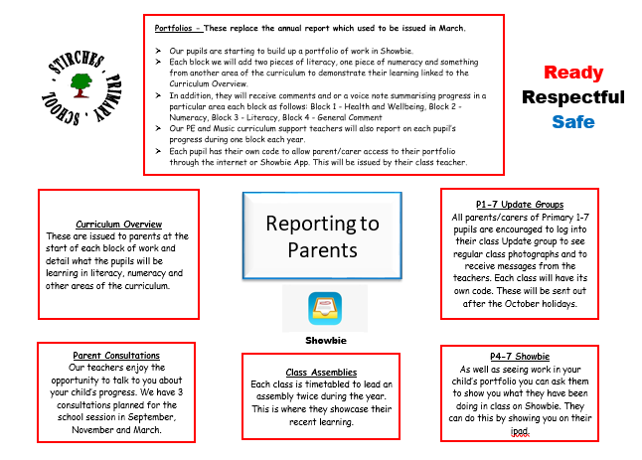

Stirches Parent Council
We have a fantastic and committed Parent School Partnership committee that meets regularly, who do great work to support the school. All parents are invited to join the parent council. This group plays an important role by supporting the school in its activities as well as advising and representing parents who have children at the school. If parents have a general concern, they should contact a Parent Council member. (Matters of a personal and private concern should, of course, be raised with the Head Teacher). Due to all their hard work and fundraising events, we are able to offer our children a range of opportunities. The parent council are always looking for new members to join them. If you would like to find out what they do, or if you would like to join, let us know - it would be great to have you on-board. A copy of the Parent Council Constitution is available from the school office.

Currently, the office bearers are:
- Chairperson: Laura Millar

Contact details can be obtained from the School Office.

Transitions/Enrolments
Starting School - Enrolment
- Children entering school for the first time are enrolled in November preceding the August admission date; enrolment times are advertised in advance.
- Children who reach the age of five years before 1st March of the following year are eligible for enrolment in the P1 class beginning in August each year.
- Children who live in the catchment area of a particular school must enrol in their local school. Parents who wish to enrol their child in a school outwith their catchment area must also make a placing request to the school of their choice. Admission forms are available from the school and ELC.
- A parent wishing to enrol a child outwith the start of the session will need to make an appointment with the Headteacher to discuss school policy, answer questions and have a tour of the school. Placing request forms are available from the school office.
- During the summer term, we arrange pre-school preparation sessions. This provides opportunities for the children to become familiar with the P1 classroom and relevant staff.
- All P1 children are being assessed throughout the ELC and this continues into P1.
- Children transferring from another school, at any stage in Primary Education, can apply for admission at any time, on completion of an admission form obtainable from the school, during working hours and after discussion with the Headteacher.

Deferred Entry - Under current legislation in Scotland, parents/carers of children aged between four and a half and five at the start of the school session (those with January to February birthdays) have a choice about enrolling their child for primary school. Children can start school before they are five or can defer their start until the following August.

What must parents/carers do?
- Enrol the child at the catchment area school, where there will be an opportunity to indicate interest in deferring entry, during the period notified in the local press.
- Discuss the possibility of a deferred entry with Early Learning and Childcare staff.
- If there is agreement that the child will benefit from an additional pre-school year, the parents and the school setting will make a joint submission to the Early Years Admission Panel (EYAP). If there is not agreement, then the parents will make the submission and the setting will submit their information sheet separately.
- The EYAP consists of the Senior Education Officer (Early Years), Early Years Quality and Practice Officer and an Educational Psychologist.
- The Purpose of the EYAP is to consider applications and likely benefits for the individual children. They will accept, decline or seek further information. You will receive a letter confirming the decision and giving further instructions with regard to next steps.
You can access further information on enrolments at:
http://www.scotborders.gov.uk/info/878/schools?evacid=mp

Transfer between Primary Classes - We have strong working relationships between staff at Stirches Primary School. Clear systems for transition are in place to ensure that information regarding each child’s learning, interests, challenges and overall wellbeing are communicated effectively when progressing from one year to the next. Step Up events are timetabled towards the end of each academic year. Children will spend time in their new class and with their new teacher.

Transfer from Primary to Secondary School
Children are normally transferred between the ages of 11yrs and 12yrs so that they will have the opportunity to complete at least 4 years of secondary education. Parents will be informed of High school arrangements during their child’s P7 year. Children normally transfer from this school to Hawick High School, Tel: 01450 372429.

Stirches Primary School has close links with Hawick High School (HHS). There are regular Primary/ Secondary Liaison meetings for staff. HHS pastoral staff visit the school and meet the P7 children to discuss any concerns they may have, and also gather information from the class teachers to ensure a smooth transfer to secondary. All children in P7 also attend an additional two days High School Transition visit in June. An ‘enhanced transition’ can be arranged if there are any concerns raised by either parents or school staff. This results in extra visits to the High School, meeting key staff and becoming familiar with the layout of the building. Children with additional needs will receive additional support to make successful transitions. These will be discussed with parents to ensure a joined up approach.

Further information and advice regarding transition, enrolment and placement requests can be obtained from the following national organisations:

www.education.gov.scot/parentzone
www.enquire.org.uk
www.parentingacrossscotland.org
www.scotborders.gov.uk/info/878schools?evacid=mp

CHILD PROTECTION
- Our settings in the Scottish Borders work hard to keep our children and young people safe - all children and young people have a right to feel safe within the setting, home and community.

- Within our setting we strive to provide a safe, secure and nurturing environment for our children and young people, which promote inclusion and achievement.

- All staff in Education have a statutory and professional responsibility to take action if we have reason to believe a child is suffering, or is at risk of abuse.

- Our Scottish Borders Child Protection procedures set out what we will do if we have reason to believe a child is being abused or is at risk of abuse, either within the home or the community. These procedures are designed to ensure that children and young people get the help they need when they need it.

- All staff are aware of their child protection responsibilities and every year all staff in our setting attend a child protection update.

- Many of our staff undertake additional multi-agency child protection training.

- Every setting has a Child Protection co-ordinator who has the responsibility for overseeing child protection concerns as well as those young people who are care experienced within the setting.

- The Child Protection co-ordinator for the setting is Mrs Miglis (HT) or Ms Irvine (PT) who can be contacted to discuss any concerns that may arise.

What to do if you have a child protection concern?

It's everyone’s responsibility to protect children.

If you have any concerns that a child is being harmed or is at risk of harm, please call without delay

01896 662787 (Duty Children and Families Social Work Team)

01896 752111 (Out of office hours that covers all areas)

Emergency contact
If you consider a child or young person is in immediate danger, call the Police on 999 immediately

Need more information about keeping our children and young people safe?
This link takes you to the Scottish Borders Child Protection Committee online website where you can find some suggested links to websites to better inform you about safety issues such as Internet safety and Child Sexual Exploitation as well as letting you know about opportunities for training in Child Protection. You can also find the Scottish Borders Child Protection Procedures on this website.
http://onlineborders.org.uk/community/cpc

Additional Support Needs
The majority of children and young people are able to access their curricular programme at school without the need of additional help other than that which any teacher will provide in any classroom. However, at any point in their lives children or young people may need extra help with their education. This may be for any reason and at any time. This is often referred to as additional support for learning or having additional support needs. Some examples of why a child/young person may require extra help with their education are:
• Bereavement or family illness
• Problems at home
• Bullying
- Behaviour
• Being particularly gifted or able
• An illness, disability or sensory impairment
• Having English as an Additional Language

A child/young person’s needs may last for a short time, and the problem may be resolved easily or, their needs might be very complex, and they may require additional support for a number of years.

If you feel that your child needs additional support for learning, the first person to speak to is your child’s teacher. You have the right to request an assessment of your child. Within our school we operate a model of staged intervention where support is provided in varied ways to meet individual needs. Our approach to assessment ensures that the needs of children and young people are recognised and appropriate support can be provided.

Parents/carers are always involved in making decisions about their child’s education and we will always ask your permission before any specific referrals are made. While your child is receiving support, we will regularly review your child’s progress.

At times, parents/carers and schools may come into dispute. While we would always hope that difficulties could be resolved at the school level we recognise that parents or young people may wish to formalise their concerns. To assist with this we have a complaints procedure and also offer independent mediation and adjudication. It is also possible under certain circumstances to refer the case to the Additional Support Needs Tribunal for Scotland. If you believe your child has additional support needs, Scottish Borders Council publishes a range of informative advice. Visit the following website for further details.
www.scotborders.gov.uk/info/886/additional_support_needs
The statutory framework for Additional Support for Learning is the Education [Additional Support for Learning] [Scotland] Acts 2004 and 2009. For more information, you can contact:
- Enquire, the Scottish advice service for Additional Support for Learning. They have a wealth of information, including practical guides and fact sheets for both parents/carers and young people. You can find the website at www.enquire.org.uk, or ring them on 0345 123 2303.
- Scottish Independent Advocacy Alliance, a charitable body registered in Scotland under registration number SC033576; www.siaa.org.uk
- Scottish Child Law Centre, a charitable body registered in Scotland under registration number SCO1274. www.sclc.org.uk”

The Educational Psychology Service
The Educational Psychology Service (EPS) works with all SBC schools to support children’s learning and wellbeing. We provide advice and training to school staff on how children learn and advise on ways to help children who require support. If requested by the school, we can arrange follow-up for individual children and young people, together with their families and teachers, to help support their learning, or with social or emotional issues. This is generally achieved by meeting the children, their families and school staff, to review the support they have already received and agree ways in which we can all help your child in school. In some cases, we may agree that a psychologist will work on a one-to-one basis with your child to obtain a clearer picture of how they can best be supported.
If you have any worries about your child, please contact their school, in the first instance, to arrange a meeting to discuss your concerns. All schools have access to a range of support Services and your child’s Head Teacher will be able to advise you about when the EPS may be able to help. Further information about the EPS is available on the Scottish Borders Council website. Here you can access a downloadable leaflet for parents and carers, which explains in more detail how we may be able to work with you to support your child in school. Please see www.scotborders.gov.uk/EPS

GIRFEC
Getting It Right for Every Child (GIRFEC) is the national approach in Scotland to improving outcomes and supporting the wellbeing of our children and young people by offering the right help at the right time from the right people.

The GIRFEC approach aims to make it easier for parents, children, young people and the services that support them – such as early years’ services, schools and the NHS – to work together to get it right.

Practitioners work together to support you and your child, working across organisational boundaries and putting your child and you at the heart of decision making, ensuring we give all our children and young people the best possible start in life.
GIRFEC means that everyone working with Scottish Borders children, young people and their families are encouraged to:
- Ensure children, young people, and their families get the help they need when they need it and are central to the process of finding solutions.
- Use one consistent and equitable approach, actively share information to agreed protocols and work more effectively together to improve outcomes for children and young people.
- Be clear about personal responsibility to do the right thing for each child/young person.
- Work with children, young people and their families, using a collaborative approach with fewer meetings. This should ensure children, young people and their families give information only once, and enables the development of one plan to meet all their needs.
- Respond to children and young people and take appropriate, proportionate and timely action with the minimum of paperwork, bureaucracy and duplication.

GIRFEC is part of the Children and Young People (Scotland) Act 2014. If you would like any further information, please ask your child’s Headteacher.

Medical

Accidents
In case of an accident at school, trained first aid staff will attend to any medical incidents. If the incident is serious, parents are immediately informed and arrangements are made to ensure that the child is seen by medical personnel. An Accident Book is kept in the school and relevant details may be seen by the parents of the child concerned.

Prescribed Medication
There is no legal or contractual duty on school staff to administer medication and supervise the children taking it. If it is agreed by management to take on this responsibility it is purely on a voluntary basis. It is presently only permissible to give children prescribed and/or complex medication. We are unable to administer non prescribed medication. When a child is in receipt of prescribed medication it is helpful in the first instance to consider whether or not it is necessary for the medication to be taken during the school day. This requires parents planning the administration of the child’s medication to be done in out-of-school hours and includes making arrangements for the child to return home at lunch times where possible. Where this is not possible and schools are asked to administer prescribed medication, the following procedures should operate:

- All prescribed medication should be accompanied by clear, written, signed instructions from parent/guardian on the form “Request for the School to Give Prescribed Medication” (available from the school office), which includes dose, frequency, and duration of course and date prescribed. These details and the children’s name should be clearly marked on the medication container.
- All prescribed medication, in the smallest practical amounts should be brought to the school by the parent/carer and should be delivered personally to management or a designated member of staff.
- The renewal of any medication, which has passed its expiry date, is the responsibility of the parent. The school will contact parents/guardian if medication remains uncollected.
- Where any change in medication occurs, clear written instructions from parents/guardian should be provided for school staff
- All information regarding medication will expire at the end of each school session. If the administration of medication is to continue all relevant information must be confirmed in writing at the commencement of the new session.
- A written record will be kept on the appropriate form indicating administration of all prescribed medication to children. This record will be kept together with the instruction, checked on every occasion and completed by the member of staff administering the medication. The record should give the date and time of administration, the name of the medicine, the dosage, the name of the children and the name of the staff member.
If your child has been vomiting or has diarrhoea, they MUST stay off school for 48 hours afterwards to reduce the spread of illnesses.

Emergency School Closure
In the event of an Emergency Closure e.g. the breakdown of the heating system the school has an action plan which will be implemented.
- Autumn Term - Parents complete an Emergency Transport Form with two emergency contact numbers.
- Headteacher ascertains from Education Department whether school may be closed.
- In the event of closure, parents or emergency contact will be contacted to ensure that there is someone to receive the child.
- N.B. NO child will be released without contact being made.

In the event of a fire the children will be evacuated to Wilton School before being dismissed. Regular fire practices are held every term.

New Carer’s Act for Scotland

A young carer is someone who is under 18 years of age or who has reached 18 and still a pupil at school and provides or intends to provide care for another individual. A number of young carers do not always identify themselves or wish to be identified. Young carers undertake a number of tasks for the people they live with and look after. They are often left alone to do things like washing, cooking, shopping, paying bills, collecting medication or helping to look after younger brothers or sister. This means they might not have as much time to complete work at home which has an ongoing effect on progress and learning or attend clubs and after school’s activities therefore missing out on the social aspects of school. Within Stirches Primary School we want our young carers to enjoy school and that it is a positive place to come and they feel included. Please let us know if there are difficulties meeting deadlines with work, arriving on time or any other issues which affect a young person.

Employment of Children
Children under the statutory school leaving age can only be employed within the terms of the bye-laws on the Employment of children. These regulations allow anyone to be employed at 14 years but under certain circumstances children under 13 years of age can be employed, and for those over the age of 13 there are limits on the hours and type of employment which are allowed. Parents and employers must both complete an application form for an employment permit before the employment begins. Forms and application forms are available from the school office. Further details can be obtained from HQ Operations, Children & Young People Services, Scottish Borders Council, Newtown St Boswells, TD6 0SA
Further information can be found at:
https://www.scotborders.gov.uk/info/20025/licensing/670/employment_byelaws_for_children_and_young_people/1

DATA PROTECTION
Scottish Borders Council is a local authority established under the Local Government etc. (Scotland) Act 1994 and its headquarters is based at Newtown St Boswells, Melrose TD6 0SA. You can contact our data protection officer by post at this address, or by email at: dataprotection@scotborders.gov.uk , or by telephone – 0300100 1800.

Why we need your information
Every child of school age has the right to be educated. A child is of school age if he/she has attained the age of 5 but has not attained the age of 16 years. The term “young person” applies to a pupil over school age, but who has not attained 18 years. The education authority has a duty to provide education to any young person who is still a school pupil.
We need to collect, use and store personal information about you and your child/ren to enable us to provide your child/ren with an appropriate education. We provide these services to you as part of our statutory function as your local authority under:
- The Education (Scotland) Act 1980, Education (Scotland) Act 1980
- The Education (Placing in Schools etc. Deemed Decisions) (Scotland) Regulations 1982
- The Standard in Scotland’s Schools Act 2000
- Education (Scotland) Act 2016
We also use your information to verify your identity where required, contact you by post, email or telephone to maintain our records.

Who we will share information with
We will share information with health and wellbeing services and may share information with other external agencies and organisations who provide or assist with educational provision and with online payment solution providers.
- The Scottish Government for examination, career guidance and monitoring purposes.
- ParentPay, ESP Systems and CRB to allow the school to offer cashless catering and to receive payment for school trips and events;
- Groupcall to allow the school to communicate with you;
- The NHS for health monitoring;
- Netmedia to enable the online arrangement of parent’s evenings;
- Internal Scottish Borders Council departments to allow the provision of catering and transport.
On each occasion, the recipients are bound to the terms of a Data Sharing Agreement and accordingly will only use your child’s data for the specified purpose. This data sharing is in accordance with our Information Use and Privacy Policy and covered in our full privacy statement on our website.
We are also legally obliged to share certain data with other public and regulatory bodies such as Education Scotland, Police and NHS will do so where the law requires this.
Your information may also be shared and analysed internally in order to provide management information, inform service delivery reform and similar purposes to meet our duty to achieve best value and continuous service improvement.
We are legally obliged to safeguard public funds so we are required to verify and check your details internally for fraud prevention. We may share this information with other public bodies (and also receive information from these other bodies) for fraud checking purposes.

How long do we keep your information for?
We only keep your personal information for the minimum period amount of time necessary. Sometimes this time period is set out in the law, but in most cases it is based on the business need. We will retain a copy of your child’s educational record up until they reach the age of 25.

Photographs/videos
Photographs and videos may be taken by staff in the school, media and other parents for a variety of reasons for example Sports Day, celebrations of achievement, charity events, excursions etc. The school your child attends may wish to display or show photographs or videos taken by themselves, in print, in various locations or by electronic means such as a website. Likewise, the media or other parents may wish to use the images of pupils in various ways. We ask you at the time your child enrols at one of our schools if you are happy for images of your child to be used in this way and we try to ensure you are aware of, and understand, such possible use of your child’s image and that you have consented.
Any permission given will remain in force during your child’s primary and secondary schooling until you indicate that you wish to withdraw your consent. You can do this by contacting the head teacher of your school as soon as possible.

Your Rights
You have the right to request access to any personal data held about you by the Council. You can also request that we restrict the use of your information or even object to any further processing. You can do this by contacting the Data Protection Officer using the contact details provided above. We will respond to your request within thirty calendar days.
For more information on your rights please visit our website http://www.scotborders.gov.uk/DPYourRights or if you would like a hard copy of this information, please contact us using the contact details provided above.

SBC’s Implementation of British Sign Language Plan
The Council’s BSL Plan 2018-24 has seven holistic actions. These actions are consistent with the ten long term goals of the National BSL Plan in Scotland, which are, early years and education; training and work; health, mental health and wellbeing; transport; culture and the arts; justice and democracy.

These goals represent the Scottish Government’s aim “to make Scotland the best place in the world for BSL users to live, work and visit.”

The Council will implement measures to promote awareness of BSL and the use of BSL, with the long term goal being that across Scotland information and services will be accessible to all BSL users*.

Contact Scotland –BSL is an online British Sign Language interpreting service that allows deaf people across Scotland to access services free and available 24 hours a day throughout the year: https://contactscotland-bsl.org/ If you need a face-to-face meeting please get in touch with the school.

Complaints Policy
Parents are encouraged to share concerns or issues with the school at an early stage. Our policy is to deal with any issues promptly and as far as possible, an ‘open door’ policy is adopted. Should you wish to comment on or make a complaint about any aspect of provision made by the school, you should write in the first instance to the Head Teacher whose address is given in this handbook. Once the Head Teacher has responded, and if you are still dissatisfied you should use the procedure set out in the Scottish Borders Council leaflet “Complaints Procedure”. This leaflet is available online at the following address. Complaints can also be made online using this link.
https://www.scotborders.gov.uk/info/20016/have_your_say/155/make_a_complaint

Complaints will be recognised, recorded and dealt with in accordance with SBC Complaints Handling Procedures.

If your complaint is about how we have handled your personal information, you can contact our Data Protection Officer by email at dataprotection@scotborders.gov.uk or by telephone on 0300 100 1800.
However, you also have the right to lodge a complaint about data protection matters with the Information Commissioner's Office, who can be contacted by post at:
Information Commissioner's Office
Wycliffe House
Water Lane
Wilmslow
Cheshire, SK9 5AF

You can visit their website for more information https://ico.org.uk/make-a-complaint/ .
If your complaint is not about a data protection matter you can find details on how to make a complaint on our website:
https://www.scotborders.gov.uk/info/20016/have_your_say/155/make_a_complaint/1

Disclaimer
Whilst information provided within our Handbook is considered to be correct at the time of printing (November 2023), it is possible that there may be some inaccuracy as we progress through the session due to changes which may occur.

On request, we can provide a hard copy of the Handbook alternatively you can access a copy online at https://www.scotborders.gov.uk/downloads/download/392/school_handbooks

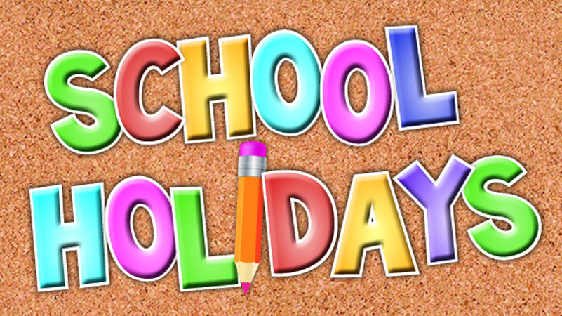

2023 -2024

Autumn term
- Monday 14 and Tuesday 15 August 2023 - staff resume Inset (closed to pupils)
- Wednesday 16 August 2023 - pupils resume

Mid-term holidays
- Monday 9 October to Friday 13 October 2023
- Monday 16 October 2023 - In service day
- Tuesday 17 October 2023 - Pupils resume
- Monday 27 November 2023 - St Andrew's Day, schools closed
- Tuesday 28 November 2023 - pupils resume
- Thursday 21 December 2023 - last day of term for pupils and staff

Christmas holidays
- Friday 22 December 2023 to Friday 5 January 2024

Winter/Spring term
- Monday 8 January 2024 - Term starts, all resume

Mid-term holiday
- Monday 12 to Friday 16 February 2024, mid-term break, Monday (inset for staff)
- Monday 19 February 2024 - School resumes
- Thursday 28 March 2024 - last day of term

Easter holiday
- Friday 29 March to Friday 12 April 2024

Summer term
- Monday 15 April 2024 - all resume
- Monday 6 May 2024 - May Day holiday
- Tuesday 7 May 2024 - in service day (school closed to pupils)
- Wednesday 8 May 2024 - pupils resume
- Friday 7 June 2024 & Monday 10 June 2024 - Hawick Local Holiday
- Friday 28 June 2024 - last day of term

