Ednam Primary School

School Handbook
2023/24

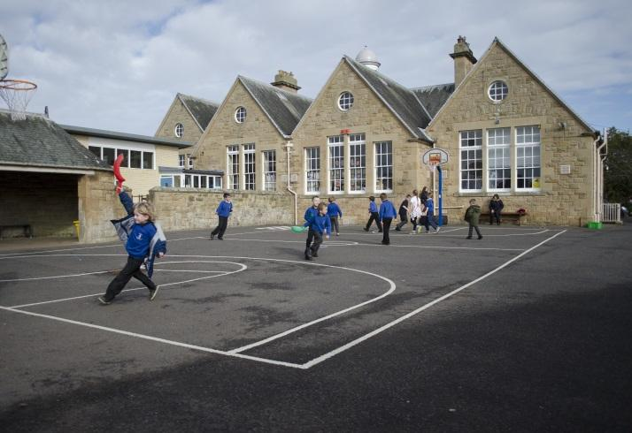

Ednam Primary School
Duns Road
Ednam
Kelso
TD5 7QJ
01573 224172
Ednamps@scotborders.gov.uk

https://www.facebook.com/EdnamPrimarySchool/

Alphabetical Index | Page/s
Address | 4
Assessment | 9
Attendance and Absence | 9
Breakfast Club | 9
Child Protection | 29
Concerns and Complaints | 10
Contacting the School / School Information | 4
Curriculum | 7-8
General Data Protection GDPR) | 25-28
Educational Psychology Service | 26
Emergency Closures | 10/11
Enrolment | 10
Foreward by Headteacher | 3
Health & Wellbeing | 7/11/ 19-21
History of the School | 4
Homework | 11
Holidays & Term Dates | 6 &12
GIRFEC | 25
Medical, Dental & Welfare Services | 11
Meeting Pupil’s Needs | 11-12
Nursery | 12
Parent Consultation | 12
Parent Council & Parental Involvement | 13
Parking | 12-13
Partner Schools | 13
Playground Supervision | 13
Positive Behaviour | 13
Pupil Involvement | 14
School Day | 5
School Improvement Plan | 15
School Meals | 16
School Values & Vision | 5
Sign Language Plan | 22
Staffing | 6
Support for Learning | 19-20
Term Dates | 6
Transitions | 17
Transport | 17
Uniform | 18
Young Carers | 24

Foreword by Head Teacher

Dear Parents

Welcome to Ednam Primary School.

The purpose of this handbook is to give you information about our school and its ethos. The handbook is not intended to take the place of direct communication with you, which we welcome and strongly encourage. It is through visiting our school and speaking to staff and children that you will get a real sense of our school.

We are committed to working in partnership in respect of your child’s care and learning and we look forward to developing a positive and helpful relationship with you and your family. There is a strong tradition of parental involvement in school.

Ednam is a small, rural school. Children and staff get to know each other well and work together in an environment of encouragement and support. Pupils are helped and challenged as individuals and as part of the school team. Friendships develop across age ranges and children learn to be respectful and respected in a safe and caring place.

We plan for children to enjoy and be motivated by their learning and they are supported to achieve their best. Individual targets are set and worked towards with input from pupils and parents. The makeup of our classes allows children to work at their own level regardless of age and stage. Individual, collaborative and group learning are features of our approach. The Curriculum for Excellence gives all children a broad, general education from the ages of 3 – 18.

Ednam is a partner school with Sprouston primary and is part of the Cheviot Learning Community; this ensures close working with other local primaries and Kelso High School.

Please do not hesitate to get in touch with myself or a member of staff at any time; we welcome communication.

Yours sincerely

Catriona Finn

(Mrs) Catriona Finn

About our School

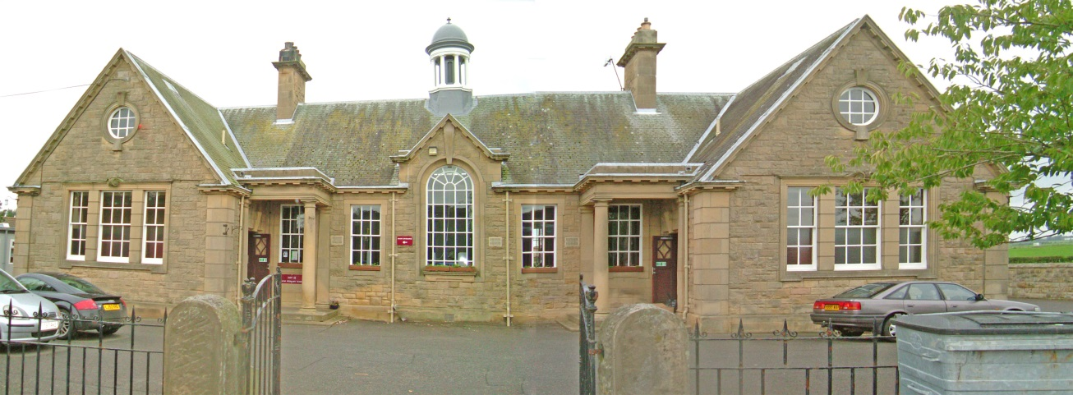

Our school serves the villages of Ednam and Stichill and surrounding rural areas. We also have a number of pupils in school who live out with the catchment area and whose parents have applied for them to join the school. If your child is out with catchment you can make a placing request online to SBC. The placing request will be considered in line with current staffing and a decision will be made. If successful you will be responsible for transporting your child to and from school.

In August 2023 the school roll was 45 with 25 children in P1-4 with Mrs Murray John & Mrs Shiel and 20 children in P5-7 with Mrs McIntosh. In nursery there are 9 children with Mrs Fox, Mrs Crombie , Mrs Pennington & Miss Milligan.

The 2 classroom school was built in 1911 and has been extended to provide a nursery in the main building. There is an extensive outdoor area for play, P.E and gardening.

School Information

Address | Ednam Primary School  Duns Road  Ednam  Kelso  TD5 7QJ
Telephone | 01573 224172
E mails | ednamps@scotborders.gov.uk (Admin)  Catriona.Finn@scotborders.gov.uk (Head Teacher)
App | Xpressions App (for parents only)
Website | https://ednamprimary.school
SBC | www.scotborders.gov.uk
The School Day
In keeping with all Scottish Borders schools we work within an asymmetric week at Ednam with four longer days on Monday – Thursday and one shorter day on Friday.

Monday to Thursday
Start | Break | Restart | Lunch | Restart | Finish
8:45 am | 10:15 am | 10:30 am | 12:15 pm | 1:00 pm | 3:15 pm

Friday
Start | Break | Restart | Brunch | Restart | Finish
8:45 am | 10:15 am | 10:30 am | 11:50 am | 12:20 pm | 12:30 pm

The Nursery Day
Nursery is open five days a week. Please see times below.
Children attending nursery can order a free hot meal on ParentPay or they can bring a packed lunch from home.

Day | Start | Finish
Monday to Thursday | 8:45 am | 3:15 pm
Friday | 8:45 am | 12:45pm

Vision and Values
We work towards the aspirations of Curriculum for Excellence and within SBC’s Respectful Relationships policy, which states that all children will be successful learners, confident individuals, responsible citizens and effective contributors.

The Scottish Government’s ‘Getting it Right for Every Child’ (GIRFEC) approach is about how practitioners across all services for children and adults meet the needs of children and young people, working together where necessary to ensure they reach their full potential.

We worked with pupils, staff and parents to develop our key values in school. We have highlighted the following values and are talking about them and taking them forward in school life:

Respect Perseverance
Kindness Inclusion
Being the best we can be

Staff List
Headteacher Mrs Catriona Finn
P1-3 Teachers Mrs Barbara Shiel and Mrs Wendy Murray John
P4-7 Teacher Mrs Julie McIntosh
Principal Teacher Mrs Barbara Shiel
Support for Learning Teacher Mrs Isla Burgher
CST P.E Mrs Denise Fairbairn
CST Music Mrs Ailsa McNeill
Early Years Officer Mrs Carol Fox
Early Years Practitioners Mrs Joanne Pennington, Mrs Jackie Crombie & Miss Sarah Milligan
School Administrator Mrs Marion Nairn
Additional Needs Assistant s Mrs Elaine Douglas & Mrs Marley Arnold
Playground Supervisors Mrs Elaine Douglas & Mrs Marley Arnold
Breakfast Club Mrs Marion Nairn
Kitchen Assistant Ms Alexandra Bartram
Cleaner Ms Hannah Worrall
Janitor Mr Alan Currie

School Term and Holiday Dates for 2023/24

School term dates for 2023-24
Autumn term
Monday 14 August 2023 - staff resume, in service day
Tuesday 15 August 2023 - in service day
Wednesday 16 August 2023 - pupils resume
Friday 6 October 2023 - Last day for staff and pupils
Monday 16 October 2023 In service day
Tuesday 17 October 2023 All resume
Monday 27 November 2023 - St Andrew's Day, schools closed
Tuesday 28 November 2023 – school closed (casual holiday)
Thursday 21 December 2023 - last day or term for pupils and staff

Winter term
Monday 8 January 2024 - all resume
Friday 9 February 2024 - last day of term for pupils, February holiday
Monday 12 February 2024 – Friday 16 February- school closed
Monday 19 February – school closed to pupils (staff in service day)
Tuesday 20 February 2024 - pupils resume
Thursday 28 March 2024 - last day of term for pupils and staff

Summer term
Monday 15 April 2024 - all resume
Monday 6 May 2024 - May Day holiday, school closed
Tuesday 7 May 2024 - staff resume, in service day
Wednesday 8 May 2024 - pupils resume
Friday 28 June 2024 - last day of term for pupils and staff

Curriculum
Curriculum for Excellence (2010) encompasses the following elements:

The ethos and life of the school as a community
- a positive climate of respect and trust is established within the school based on shared values
- children are encouraged to contribute to the life of the school and to take on responsibilities

Experiences and outcomes
These set out learning outcomes under the three core areas of the curriculum, Language, Mathematics and Health and Wellbeing and through the other areas Expressive Arts, Religious and Moral Education, Sciences, Social Studies and Technologies.

Interdisciplinary Learning
Children may learn through courses of study which link experiences and outcomes from more than one curriculum area in order to contextualise and deepen learning.

Personal Achievement
Children have opportunities to achieve within and outwith the classroom and their achievements are recognised.

Principles and Entitlements
The curriculum is designed on the basis of the following principles:
- Challenge and enjoyment
- Breadth
- Progression
- Depth
- Personalisation and choice
- Coherence
- Relevance

Areas of the Curriculum

Mathematics and Numeracy
This includes information handling, number, money, measurement and shape, position and movement.

Literacy and Languages
Within the contexts of Literacy, English and Modern Languages we cover Listening and Talking, Reading and Writing. Pupils in P1-7 also learn French. A third language will be introduced to children in P4-7 by end of this session.

Health and Wellbeing
This covers mental, emotional, social and physical well-being, building resilience, P.E, physical activity and sport, planning for choices and changes, food and health, substance misuse and relationships, sexual health and parenthood.

Social Studies
This covers People - past events and society, People - place and environment and People in society, economy and business.

Sciences
Planet Earth, biological systems, forces, electricity, waves and materials

Expressive Arts
Art and Design, Drama, Music and Dance.

Religious and Moral Education
Exploration of meaning, value and purpose in life and the study of how such beliefs and values are expresses including through Christianity and World Religions.

Technologies
Developments in society and ICT to enhance learning. Includes business, computing science, food & textiles and craft, design, engineering and graphics.

Global Citizenship – Within the curriculum and through our regular assemblies the children explore global issues and events. They learn about the UNCRC and how important that all their rights are recognised.

Curriculum for Excellence Levels
Most children will learn through the levels as listed below but this is dependent on individual needs and aptitudes.
- Early – the pre-school years and P1 or later.
- First – to the end of P4, but earlier or later for some
- Second – to the end of P7, but earlier or later for some.

Other Activities in and out of School
Additional activities are offered to children in different age groups both during and out with the school day.
Our Sports Development Officer, Lorna Esson, is very active and supportive in organising additional sporting activities as are a number of coaches and volunteers.

Examples of activities are: badminton, cricket, curling, gymnastics, rugby & tennis

A number of holiday activities are also offered in Kelso.
Ednam Primary School A-Z

Assemblies
These are held weekly throughout the year. Assemblies give a balance of opportunities to celebrate children’s achievements, to support positive behaviour and moral development and to take part in religious observance. They regularly focus on our programme of work in building resilience.

Assessment
Assessment of children’s progress and planning for next steps is on-going as part of the curriculum. Class teachers monitor this and record appropriately. There is also a programme of formal screening and assessment at certain points in the school year.

Attendance & Absence
If your child is going to be absent from school please contact us as soon as possible by telephone, 01573 224172. Please tell us the reason for their absence and likely return date. If your child does not come in to school or nursery, and we have not heard from you, we will contact you.
Please keep the school updated with contact details: addresses, emergency contacts and telephone numbers must be correct at all times.
We encourage children to arrive in time for school starting. Late children should report to the school office on arrival. Lateness is recorded in the school register.
We will contact you if your child’s attendance drops below 90% or if they have had more than 10 lates.

Breakfast Club
The school runs a breakfast club every morning before school. Children can attend from 8:00 and have breakfast before joining children in the playground at 8:30. The breakfast club is free for all P1-7 children.

Classes – Composite Classes
In session 2023-2024 there are two classes at Ednam Primary. These are composite classes i.e. made up of a number of age groups of children. The classes are Primaries 1, 2, 3 & 4 taught by Mrs Shiel (Monday – Tuesday) and Mrs Murray-John (Wednesday – Friday) and Primaries 5, 6 & 7 taught by Mrs McIntosh.

Our classes are relatively small and pupils are treated as individuals. The pupils follow programmes of work suitable to their stage and needs.

A copy of the SBC Composite Class Policy is available from www.scotborders.gov.uk

Communication
We are very aware of the benefits of strong communication and we try hard to ensure there are appropriate methods for sharing information. Newsletters are sent out on a regular basis via Groupcall Xpressions App & email. For urgent matters: SMS text will be used e.g. for daily attendance and school closures. Groupcall Xpressions or email will be used for all other communications.

The school uses Groupcall Xpressions App and website https://ednamprimary.school to share information and news.
Letters are occasionally issued for specific purposes to particular classes or pupils. At times you will be asked for permission for your child to take part in an activity such as trips out of school.

Please let us know of any significant information that may affect your child in school.

Concerns & Complaints Procedures
If something goes wrong or you are dissatisfied with our services, please tell us and we will do our best to put things right. We deal with all complaints in accordance with the Scottish Borders Council complaints handling procedure. This can be found on the Council website: www.scotborders.gov.uk.

If you do want to make a complaint, you can do it either in person, by phone, in writing or by email. You can do this through your child's teacher or a senior member of staff (the Head teacher or a Principal Teacher) or indeed any member of staff. You can also make a complaint via the complaints form on the council website www.scotborders.gov.uk .

If we are unable to resolve your complaint, or if you believe your complaint requires formal investigation, you may make your complaint directly to the Education and Lifelong Learning Department at Scottish Borders Council. Again this may be done in a variety of ways:
- in person at a Scottish Borders Council customer services office
- by phoning Customer Advice and Support Service on 0300 100 1800
- by email to : PeopleComplaint@scotborders.gov.uk
- in writing
- to your local councillor
- via the complaints form on the council website www.scotborders.gov.uk .

Educational Visits
Field trips, activities and visits are arranged for classes to support and enhance learning and compliment the curriculum. Pupils will make visits within the local area and further afield, including a residential trip for pupils in P6/7. We value outdoor learning and the benefits that educational visits can give. You will be asked to complete a signed permission slip for children to take part in outings.

Emergency Closures
In the event of an emergency closure for example in severe weather, Radio Borders will broadcast information and the Groupcall text system to parents will be used. It is possible that pupils not entitled to transport will remain in school until the end of the day and that the children who travel by bus will be collected and taken home. It is important that school and pupils know where children are to go in such circumstances. See also Extreme Weather.

Enrolment Arrangements
Enrolment for P1 takes place in November for the following session in August. Enrolment for Nursery is in January for the following session in August or the month after a child’s third birthday. As a general rule pupils accepted for enrolment for school should have reached the age of five by 28th February of the following year.
Extreme Weather
In the event of extreme weather decisions will be made locally about whether a school is able to open or not. In the event of the school remaining open it is the parent’s decision as to whether it is safe for your child to travel to school. This absence would be recorded as authorised under extreme weather. It is possible that the school would remain open with fewer staff members if weather prevents some staff travelling to work. We will keep you up to date with any closures through Groupcall and also through Radio Borders
More information can be found here on the Scottish Borders Council website -
http://www.scotborders.gov.uk

Holidays during term time – statement from Scottish Borders Council
Taking family holidays during the school term is disruptive to your child’s education as well as having an impact on the other pupils in the class and the teachers. Parents should do everything possible to take their holidays during the designated school holiday dates and only in very exceptional circumstances consider taking holidays during term time. Parents are asked to accommodate this request in the interest of their own children and the smooth running of the school.
Time off school for family holidays is recorded as ‘unauthorised’

Homework
Homework gives opportunities for practice and consolidation of learning as well as for opportunities to find out information and carry out small projects. Homework also offers parents a way to be involved with their children’s learning and is a positive contact between home and school. Every pupil has a homework diary and further information will be given by class teachers.

Learning Community
Ednam is part of the Cheviot Learning Community and as such has links and works closely with schools and services in the Kelso and Jedburgh areas.
Our pupils have opportunities to meet with those from Sprouston, Broomlands, Edenside, Morebattle and Yetholm at certain times throughout the year at sporting events and other organised activities. Transition activities are organised for our P7 pupils with their peers from other schools in the cluster.

Medical, Dental & Welfare Service
Minor issues such as bruises or small cuts/grazes are treated in school by staff, usually a first aider. When professional medical treatment is considered necessary, or when a child is thought to be unfit to complete the school day, parents will be contacted and asked to collect the child from school. It is important that we have a current emergency contact number. If the main contact cannot be reached a member of staff will ensure that the child is taken for medical help or cared for in school.

To safeguard the interests of both pupils and staff, any request for prescribed medicine to be administered during the school day MUST be accompanied by a parental request form, available from the school office. This will give clear instructions as to type, quantity, frequency and method of administration and should be signed and dated by parents.

It is parents’ responsibility to inform the school of any special medical condition or requirement relating to their child.

Because of allergies we ask that children do not bring foods containing nuts into school.

Parents will be told of visits to school by health professionals for example for flu immunisation. All pupils will be seen at times for screening purposes of eyes, ears and teeth and if there are any concerns parents are informed immediately. The School Nurse visits regularly. Referrals can be made to Occupational Therapy, Speech and Language Therapy and Physiotherapy services.

All pupils brush their teeth after lunch. The toothbrushes and toothpaste are provided by NHS Childsmile and the programme is monitored by them.

Should you have a concern about your child’s well-being at school, please do not hesitate to contact the school. We will arrange a time to meet with you and discuss the matter.

Meeting Pupils’ Needs
All children are appropriately supported in their learning. Consultation takes place between staff who work with children and input and support is planned as necessary. A Support for Learning Teacher is in school for a morning each week and works directly with pupils who, for whatever reason, require additional support for learning. This teacher also acts as a consultant to class teachers and Additional Needs Assistants (ANAs). Pupils may be withdrawn from class to have the help of a specialist or they may be given support in a class situation, whichever is deemed to benefit the child. Parents are invited to discuss the support children receive in school.
We regularly work with other professionals who support staff and pupils, including the Educational Psychologist, Behaviour Support, Home School Link Worker, Speech and Language Therapist, School Nurse, Dental Health and others.

Nursery – Early Learning and Childcare (ELCC)
Our nursery class provides a nurturing and stimulating environment for the introduction and developments of learning and socialisation for children from the age of three. The pre-school class is now called ELCC4 and ante-pre ELCC3. A separate handbook relating to the nursery is available from the school office.

Parent Council
All parents are members of the Parent Council and may be involved in a number of ways. All are invited to attend the Parent Council meetings and to put items on the agenda. Being an active member allows parents to be involved in their child’s education and in the community of the school. The Parent Council’s roles include:
- To represent the views of the parents at the school.
- To support the work of the school, for example, by working with the school on its policies.
- To be involved in the appointment of senior staff.
- To organise social & fundraising events.
- To promote contact between all parents & the rest of the school community.
- To discuss anything that is of interest or concern to the parents.

The fundraising/social group has organised a Halloween Party, Sainsbury’s Bag Packing, and a Duck Race.

The funds raised have paid for transport to swimming lessons, end of year trip, Halloween Discos and our P7 leaver’s hoodies.

The chairperson of the Parent Council is Mrs Melissa Meek.

Parental involvement and Consultation Meetings
Opportunities are provided for all parents to meet and consult with class teachers. Formal consultations are arranged twice throughout the year. In addition there are other informal opportunities to meet staff and pupils including performances and open sessions. You should feel able to make an appointment to speak to your child’s teacher at any time throughout the school session as well as being able to catch up on an informal basis. Parents will receive termly curricular overviews so they know what their child will be learning each term. Parents have access to Showbie where they can see examples of the work their child has been doing and we encourage parents to look at this and discuss this with their child regularly.
Reports are issued annually at the end of May.

Parent Helpers
We encourage parents to be involved in the life of the school through being helpers in the classroom or for special activities and trips etc. Those who help on a regular basis are required to have a Disclosure check (PVG).

Parking and Safer Routes to School
There is no parking for parents in the school grounds or at the front of the school. You are advised to park near to the Village Hall and walk through the Dubby to the school. Transported children are dropped off and picked up from the bus lane in front of the school.

Partner School
Ednam Primary School is a partner school with Sprouston Primary. This means that there is one Head Teacher and one Principal Teacher for both schools. Mrs Finn, the Head Teacher divides her time between the schools and can be contacted at either school. There are opportunities for pupils from both schools to come together, for example for the P6-7 residential excursion, sporting events and transition activities.

Playground Supervision
Playground supervision is in place from 8:30am and at all break times. Pupils should be respectful and follow any instructions they are given by the supervisors.
In the summer months children may be allowed to play in the Dubby instead of in the playground. The Dubby field is not part of the school and children should be aware that it is a privilege to use it.

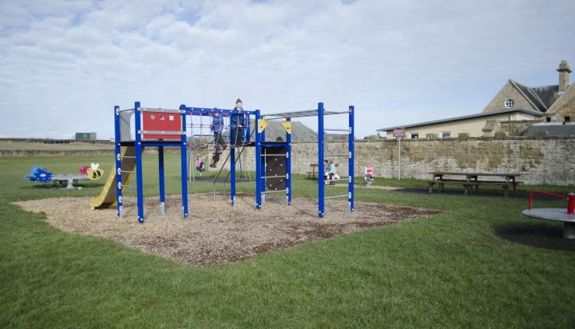

Positive Behaviour
We aim to provide a positive learning environment and to have fair and consistent approaches in school. We promote positive recognition and encourage care and respect for each other.
Both classes have behaviour systems. Each class has an individual themed system that is explained to the children on their first day after the summer.

Pupils are praised and rewarded appropriately and regularly through:
- Verbal recognition
- House-points, stars, stamps and stickers
- Certificates at assembly
- Recognition by the Head Teacher and other staff

If poor behaviour is on-going or a general area of concern parents will be informed and invited to be involved in finding solutions and monitoring progress. Improvements will be recognised. Certain forms of behaviour will lead directly to referral to the Head Teacher, such as fighting, swearing and behaviour which endangers the safety of pupils and/or staff.

SBC has a policy describing the circumstances in which as child may be excluded from school. www.scotborders.gov.uk
Pupil Involvement
We involve pupils as much as possible in planning for and reviewing their own learning and in the wider work of the school. We consult with pupils on their thoughts and wishes for the school. There is great value in providing leadership roles for our pupils. A Pupil Council operates with representatives from P3 – P7.
All pupils are allocated to one of our houses: Burleigh, Dickson, Thomson or Waldie and house captains are appointed. Friendly competition is encouraged between houses within classroom and sports activities. We always try to place siblings in the same house.

Two pupils are appointed as Junior Road Safety Officers and they have a role in promoting this through assembly presentations and competitions.

School Improvement Plan and School Improvement Report
The school produces an annual Improvement Plan when the priorities and developments for the session ahead are set out. A School Improvement Report is also produced annually with a summary issued to parents through the Parent Council.
Our strengths from last year
- Digital technologies are being used to add value to learning experiences
- Staff have a good understanding of the nurture principles and use this to support children well
- A continued focus on writing has allowed us to create more opportunities for writing across the curriculum and for celebrating children’s success in writing with our weekly writer of the week award.
- Staff use professional reading and current local and national guidance to inform their practice and make changes to school policy including the spelling and the respectful relationships policies
Priorities for this year
- Develop a more parent friendly way of sharing learning on Showbie
- Support spelling and handwriting by introducing the Kaligo app to enhance strategies already used in school
- Familiarise all staff with the materials and pedagogy within the #SBCWAY breakthrough curriculum
- Work with partners to develop our outdoor spaces and allow children to experience more of their learning outdoors
- Begin to use the materials in the Oracy section of the #SBCWAY breakthrough curriculum and carry out audits to consider the steps needs to align our current curriculum with the Literacy and Numeracy curriculum ready for implementation next year
- To share information with families about children’s rights and related school development
- To begin to introduce children’s rights into our curriculum and policy
- To embed children’s rights into the practice of all staff
- Develop and review Ednam ELC policies and procedures.

School Meals
School meals are available at a cost of £2.40 for a two course meal with the choice of two traditional dishes or a soup and sandwich option. Meals are ordered online using ParentPay. You will be given a username and password to register on ParentPay when your child starts school. From January 22 all P1-5 pupils are entitled to a free school meal in line with the Scottish Government initiative. Provision is also made for children to eat packed lunches. No glass bottles, fizzy drinks or sweets should be brought to school.
Free meals are available for eligible P6-7 pupils and application forms may be obtained from Scottish Borders Council, Customer Services on 0300 100 1800, SBC website online or your local Library.

School Polices
There are numerous policies in schools that cover various ‘school business’ and ‘teaching and learning’ issues. If you have any questions about our school, please contact the office and we will endeavour to provide further information.

Alternatively, a number of SBC-wide policies are available on the Scottish Borders website (https://www.scotborders.gov.uk/).

Security
Children enter school through the main entrance door. If they arrive late in the morning pupils must report to the school office. Visitors and parent helpers should enter via the main door and then sign in at the office.

Transitions
Transition arrangements from Nursery to Primary 1 include staff meetings, sharing of information, joint activities and planned pupil visits to Primary One. A parents’ information meeting is held in June and children and parents are invited to sample a school meal in the summer term. If children attend pre-school settings other than Ednam Nursery, staff will make a visit to meet the child in their familiar setting and to speak to staff.

As children move between classes transition arrangements are in place to ensure their learning experiences continue progressively and that learning needs are understood.

Pupils normally transfer to Kelso High School (KHS) at the end of P7. Throughout the P7 year there are a number of transition activities, including visits to the high school and visits to Ednam by KHS staff.
You will be invited to a parents’ meeting at KHS prior to transfer.

Transport
Transport for children who live over 2 miles from the school is organised by Scottish Borders Council. Children travelling by school transport are issued with a bus pass and must carry this pass at all times to show on entry to the bus.

Pupils who attend our school through parental choice from outside our catchment area are not eligible for free travel. If space exists on any vehicle contracted by SBC privilege travel may be granted - but this concession may be withdrawn if a vehicle becomes overloaded or has its quota of "entitled" travellers.

Parents should inform the school of any changes to their normal transport arrangements or if a different person other than usual parent/grandparent is collecting them at the end of the school day.

Uniform and Clothing
We actively encourage the wearing of school uniform at Ednam Primary. Apart from being practical and comfortable it gives a sense of pride and community within the school and when out and about on trips etc. The school uniform is a royal blue sweatshirt or cardigan with the school logo. Our P7 pupils can order a Jade sweatshirt. Pupils are asked to wear a navy or white polo shirt and grey or black trousers/shorts or skirts. In the summer months girls may choose to wear a blue and white gingham dress. All items of clothing and other belongings should have the child’s name clearly marked.

Sweatshirts, cardigans, jackets, fleeces and polo shirts can be ordered at any time throughout the year online from www.border-embroideries.co.uk

We discourage pupils from wearing certain items of fashion clothing, jeans, football shirts and unsuitable footwear. For safety reasons pupils should not wear high heels, bulky rings, bracelets or earrings other than studs. Jewellery should not be worn during P.E lessons.

Clothing and footwear grants are available through welfare benefits – see Scottish Borders Council website or ask at the school office for further information.

Support for Learning - Additional Support for Learning

Children may require additional support at different times throughout their school life with their learning. Our support for learning teacher works with groups of children to support them, mainly with literacy and numeracy skills. If the class teacher feels that your child would benefit from extra support, they will discuss this with you.

Inclusion and Pupils with Additional Support Needs
At any point in their lives children or young people may need extra help with their education. This may be for any reason and at any time. This is often referred to as additional support for learning or having additional support needs.

Some examples of additional support needs may include: Support from Additional Needs Assistant (ANA), Classroom Assistant or Support for Learning Teacher.
Some examples of why a child/young person may require extra help with their education are:
- Bereavement or family illness
- Problems at home
- Bullying
- Being particularly gifted or able
- An illness, disability or sensory impairment
- Having English as an Additional Language

A child/young person’s needs may last for a short time, and the problem may be resolved easily. Or their needs might be very complex, and they may require additional support for a number of years.

If you feel that your child needs additional support for learning, the first person to speak to is your child’s teacher. You have the right to request an assessment of your child. Within our school we operate a model of staged intervention where support is provided in varied ways to meet individual needs. Our approach to assessment ensures that the needs of children and young people are recognised and appropriate support can be provided.

You can also speak to a Team Leader at the local Children & Family’s Support office:

Eildon Locality Office
10-12 Gala park
Galashiels
TD1 1EU
Tel: 01896 661880

Parents/carers are always involved in making decisions about their child’s education and we will always ask your permission before any specific referrals are made. While your child is receiving support, we will regularly review your child’s progress.

At times, parents/carers and schools may come into dispute. While we would always hope that difficulties could be resolved at the school level we recognise that parents or young people may wish to formalise their concerns. To assist with this we have a complaints procedure and also offer independent mediation and adjudication. It is also possible under certain circumstances to refer the case to the Additional Support Needs Tribunal for Scotland.

The statutory framework for Additional Support for Learning is the Education [Additional Support for Learning] [Scotland] Acts 2004 and 2009. A good place to find independent information is Enquire, the Scottish advice service for Additional Support for Learning. They have a wealth of information, including practical guides and fact sheets for both parents/carers and young people. You can find the website at www.enquire.org.uk, or ring them on 0845 123 2303.

Additional support may be given in the short term or for longer periods of time. If you feel your child needs extra support, the person to speak to in the first instance is the class teacher. You have the right to request an assessment for your child either through school or your GP.

The statutory framework for Additional Support for Learning is the Education (Additional Support for Learning) (Scotland) Acts of 2004 and 2009.

Additional information can be found through the following link:

http://www.scotborders.gov.uk/info/886/additional_support_needs

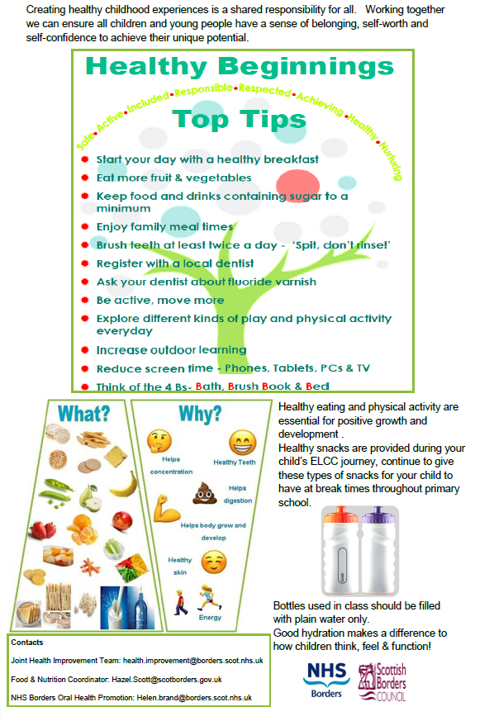


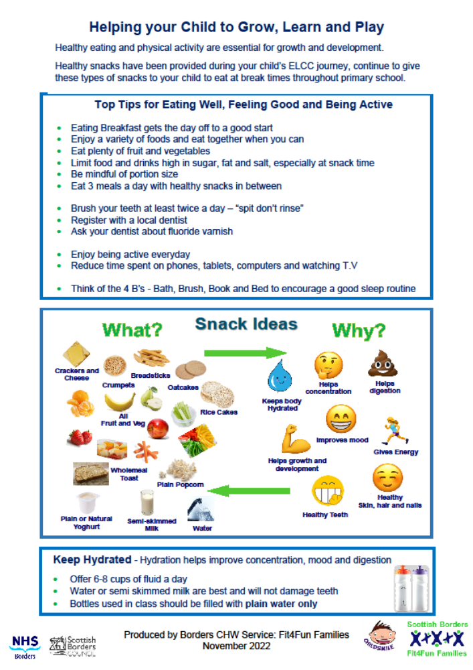

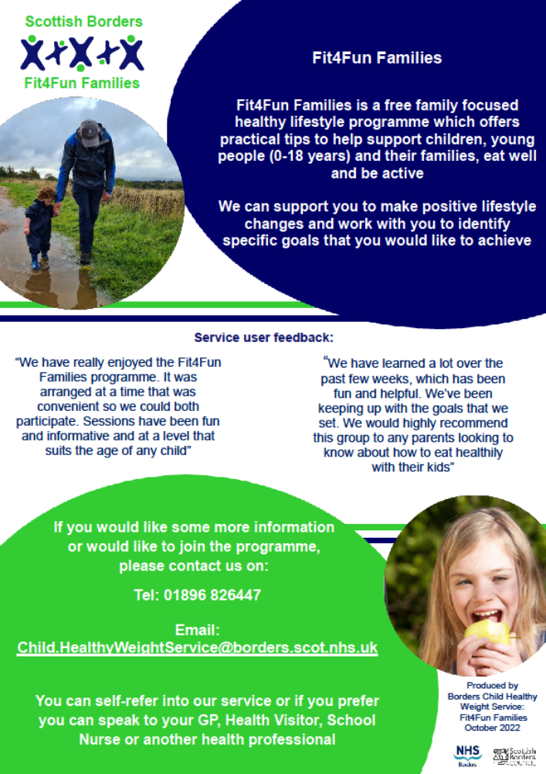

Young Carers
A young carer is someone who is under 18 years of age or who has reached 18 and still a pupil at school and provides or intends to provide care for another individual. A number of young carers do not always identify themselves or wish to be identified.

Young carers undertake a number of tasks for the people they live with and look after. They are often left alone to do things like washing, cooking, shopping, paying bills, collecting medication or helping to look after younger brothers or sister.

This means they might not have as much time to complete work at home which has an ongoing effect on progress and learning or attend clubs and after schools activities therefore missing out on the social aspects of school.
Within our Primary we want our young carers to enjoy school and that it is a positive place to come and they feel included. Please let us know if there are difficulties meeting deadlines with work, arriving on time or any other issues which affect a young person.

Council’s implementation of British Sign Language Plan
The Council’s BSL Plan 2018-24 has seven holistic actions. These actions are consistent with the ten long term goals of the National BSL Plan in Scotland, which are, early years and education; training and work; health, mental health and wellbeing; transport; culture and the arts; justice and democracy.

These goals represent the Scottish Government’s aim “to make Scotland the best place in the world for BSL users to live, work and visit.”

The Council will implement measures to promote awareness of BSL and the use of BSL, with the long term goal being that across Scotland information and services will be accessible to all BSL users*.

Contact Scotland –BSL is an online British Sign Language interpreting service that allows deaf people across Scotland to access services free and available 24 hours a day throughout the year: https://contactscotland-bsl.org/

If a BSL user requests a face to face meeting then the School is required to provide a face to face interpreter.

*Whenever we refer to ‘BSL users’ we mean D/deaf and /or Deafblind people (those who receive the language in a tactile form due to sight loss) whose first of preferred language is British Sign Language

Getting It Right for Every Child
Getting It Right For Every Child (GIRFEC) is the national approach in Scotland to improving outcomes and supporting the wellbeing of our children and young people by offering the right help at the right time from the right people.

The GIRFEC approach aims to make it easier for parents, children, young people and the services that support them – such as early years services, schools and the NHS – to work together to get it right.

Practitioners work together to support you and your child, working across organisational boundaries and putting your child and you at the heart of decision making, ensuring we give all our children and young people the best possible start in life.
GIRFEC means that everyone working with Scottish Borders children, young people and their families are encouraged to:
- Ensure children, young people, and their families get the help they need when they need it and are central to the process of finding solutions.
- Use one consistent and equitable approach, actively share information to agreed protocols and work more effectively together to improve outcomes for children and young people.
- Be clear about personal responsibility to do the right thing for each child/young person.
- Work with children, young people and their families, using a collaborative approach with fewer meetings. This should ensure children, young people and their families give information only once, and enables the development of one plan to meet all their needs.
- Respond to children and young people and take appropriate, proportionate and timely action with the minimum of paperwork, bureaucracy and duplication.
GIRFEC is part of the Children and Young People (Scotland) Act 2014 and the GIRFEC provisions are planned to be fully implemented by August 2017. If you would like any further information please ask your child’s Head teacher.

The Educational Psychology Service
The Educational Psychology Service (EPS) works with all SBC schools to support children’s learning and wellbeing.
We provide advice and training to school staff on how children learn, and advise on ways to help children who require support.
If requested by the school, we can arrange follow-up for individual children and young people, together with their families and teachers, to help support their learning, or with social or emotional issues. This is generally achieved by meeting the children, their families and school staff, to review the support they have already received and agree ways in which we can all help your child in school. In some cases, we may agree that a psychologist will work on a one-to-one basis with your child to obtain a clearer picture of how they can best be supported.
If you have any worries about your child, please contact their school, in the first instance, to arrange a meeting to discuss your concerns. All schools have access to a range of support Services and your child’s Head Teacher will be able to advise you about when the EPS may be able to help.

Further information about the EPS is available on the Scottish Borders Council website. Here you can access a downloadable leaflet for parents and carers, which explains in more detail how we may be able to work with you to support your child in school. Please see www.scotborders.gov.uk/EPS

Employment of Children
Children under the statutory school leaving age can only be employed within the terms of the bye-laws on the Employment of children. These regulations allow anyone to be employed at 14 years but under certain circumstances children under 13 years of age can be employed, and for those over the age of 13 there are limits on the hours and type of employment which are allowed. Parents and employers must both complete an application form for an employment permit before the employment begins. Forms and application forms are available from the school office. Further details can be obtained from HQ Operations, Children & Young People Services, Scottish Borders Council, Newtown St Boswells, TD6 0SA

Further information can be found at:
https://www.scotborders.gov.uk/info/20025/licensing/670/employment_byelaws_for_children_and_young_people/1
Data Protection
Scottish Borders Council is a local authority established under the Local Government etc. (Scotland) Act 1994 and its headquarters is based at Newtown St Boswells, Melrose TD6 0SA. You can contact our data protection officer by post at this address, or by email at: dataprotection@scotborders.gov.uk , or by telephone – 0300 100 1800.

Why we need your information
Every child of school age has the right to be educated. A child is of school age if he/she has attained the age of 5 but has not attained the age of 16 years. The term “young person” applies to a pupil over school age, but who has not attained 18 years. The education authority has a duty to provide education to any young person who is still a school pupil.
We need to collect, use and store personal information about you and your child/ren to enable us to provide your child/ren with an appropriate education. We provide these services to you as part of our statutory function as your local authority under:
- The Education (Scotland) Act 1980, Education (Scotland) Act 1980
- The Education (Placing in Schools etc. Deemed Decisions) (Scotland) Regulations 1982
- The Standard in Scotland’s Schools Act 2000
- Education (Scotland) Act 2016
We also use your information to verify your identity where required, contact you by post, email or telephone to maintain our records.

Who we will share information with
We will share information with health and wellbeing services and may share information with other external agencies and organisations who provide or assist with educational provision and with online payment solution providers.
- The Scottish Government for examination, career guidance and monitoring purposes.
- ParentPay, ESP Systems and CRB to allow the school to offer cashless catering and to receive payment for school trips and events;
- Groupcall to allow the school to communicate with you;
- The NHS for health monitoring;
- Netmedia to enable the online arrangement of parents evenings;
- Internal Scottish Borders Council departments to allow the provision of catering and transport.
On each occasion, the recipients are bound to the terms of a Data Sharing Agreement and accordingly will only use your child’s data for the specified purpose. This data sharing is in accordance with our Information Use and Privacy Policy and covered in our full privacy statement on our website.

We are also legally obliged to share certain data with other public and regulatory bodies such as Education Scotland, Police and NHS will do so where the law requires this.

Your information may also be shared and analysed internally in order to provide management information, inform service delivery reform and similar purposes to meet our duty to achieve best value and continuous service improvement.
We are legally obliged to safeguard public funds so we are required to verify and check your details internally for fraud prevention. We may share this information with other public bodies (and also receive information from these other bodies) for fraud checking purposes.

How long do we keep your information for?
We only keep your personal information for the minimum period amount of time necessary. Sometimes this time period is set out in the law, but in most cases it is based on the business need. We will retain a copy of your child/ren’s educational record up until they reach the age of 25.

Photographs/videos
Photographs and videos may be taken by staff in the school, media and other parents for a variety of reasons for example Sports Day, celebrations of achievement, charity events, excursions etc. The school your child attends may wish to display or show photographs or videos taken by themselves, in print, in various locations or by electronic means such as a website. Likewise the media or other parents may wish to use the images of pupils in various ways. We ask you at the time your child enrols at one of our schools if you are happy for images of your child to be used in this way and we try to ensure you are aware of, and understand, such possible use of your child’s image and that you have consented.
Any permission given will remain in force during your child’s primary and secondary schooling until you indicate that you wish to withdraw your consent. You can do this by contacting the head teacher of your school as soon as possible.

Your Rights
You have the right to request access to any personal data held about you by the Council. You can also request that we restrict the use of your information or even object to any further processing. You can do this by contacting the Data Protection Officer using the contact details provided above. We will respond to your request within thirty calendar days.
For more information on your rights please visit our website http://www.scotborders.gov.uk/DPYourRights or if you would like a hard copy of this information, please contact us using the contact details provided above.

Complaints
We aim to directly resolve all complaints about how we handle personal information. If your complaint is about how we have handled your personal information, you can contact our Data Protection Officer by email at dataprotection@scotborders.gov.uk or by telephone on 0300 100 1800.

However, you also have the right to lodge a complaint about data protection matters with the Information Commissioner's Office, who can be contacted by post at:
Information Commissioner's Office, Wycliffe House, Water Lane, Wilmslow, Cheshire
SK9 5AF

You can visit their website for more information https://ico.org.uk/make-a-complaint/ .
If your complaint is not about a data protection matter you can find details on how to make a complaint on our website:
https://www.scotborders.gov.uk/info/20016/have_your_say/155/make_a_complaint/1

Transferring Educational Data about Pupils
Education authorities and the Scottish Executive Education Department (SEED) have collected data about pupils on paper forms for many years. We are now working together to transfer data electronically through the ScotXed programme.

What pupil data will be collected and transferred?
Data on each pupil is collected by local authorities and SEED. The data collected and transferred covers areas such as date of birth, postcode, registration for free-school meals, whether a pupil is looked after by his/her local authority, additional support needs including disability, attendance, absence and exclusions from school. Pupil names and addresses are collected by their school and education authority but they are not passed to SEED. Your postcode is the only part of your address that is transferred. Data is held securely and no information on individual pupils can or would be published by SEED

Providing national identity and ethnic background data is entirely voluntary. You can choose the ‘not disclosed’ option if you do not want to provide this data. However, we hope that the explanations contained in this message and on our website will help you understand the importance of providing the data.

Why do we need your data?
In order to make the best decisions about how to improve our education service, SEED and education authorities need accurate, up-to-date data about our pupils. We are keen to help all our pupils do well in all aspects of school life and achieve better exam results. Accurate and up-to-date data allows SEED, education authorities and schools to:

- plan and deliver better policies for the benefit of all pupils,
- plan and deliver better policies for the benefit of specific groups of pupils,
- better understand some of the factors that influence pupil attainment and achievement,
- target resources better.

Your data protection rights
The collection, transfer, processing and sharing of ScotXed data is done in accordance with the Data Protection Act (1998). We also comply with the National Statistics Code of Practice requirements and other legislation related to safeguarding the confidentiality of data. The Data Protection Act gives you the right to know how we will use your data. This message can give only a brief description of how we use data. Fuller details of the uses of pupil data can be found on the ScotXed website (www.scotxed.net).

SEED works with a range of partners including HM Inspectorate of Education and the Scottish Qualifications Authority. On occasion, we will make individual data available to partners and also academic institutions to carry out research and statistical analysis. In addition, we will provide our partners with information they need in order to fulfil their official responsibilities. Any sharing of data will be done under the strict control and prior agreement of the Data Access Panel in SEED, which will ensure that no individual level data will be made public as a result of the data sharing and that these data will not be used to take any actions in respect of an individual.

Concerns
If you have any concerns about the ScotXed data collections you can email the Senior Statistician, Peter Whitehouse, at: Peter.Whitehouse@scotland.gsi.gov.uk or write to The ScotXed Support Office, SEED, Area 1B, Victoria Quay, Leith, EH6 6QQ. Alternative versions of this page are available, on request from the ScotXed Support Office, in other languages, audio tape, braille and large print.

Want more information?
Further details about ScotXed data exchanges are available on the ScotXed website, www.scotxed.net Scotxed Collections
Scottish Local Authority schools collect pupil and teaching staff data each year for statistical analysis by the Scottish Government (the ScotXed data collections). More information on the type of information collected and what is done with it can be found using the following link.

http://www.gov.scot/Topics/Statistics/ScotXed/SchoolEducation/ESPrivacyNotices

Education Statistics Privacy Notice (GDPR)
The Scottish Government and its partners collect and use information about pupils and staff in schools to help to improve education across Scotland.

The Education Statistics Privacy Notice can be found on the Scottish Government Website and is intended to provide information to pupils, teachers and parents about data collected and processed by the Scottish Government including why it is needed, their data policy and individuals’ data protection rights.

Keeping our child and young people safe in the Scottish Borders
CHILD PROTECTION
- Our settings in the Scottish Borders work hard to keep our children and young people safe - all children and young people have a right to feel safe within the setting, home and community.
- Within our setting we strive to provide a safe, secure and nurturing environment for our children and young people, which promote inclusion and achievement.
- All staff in Education have a statutory and professional responsibility to take action if we have reason to believe a child is suffering, or is at risk of abuse.
- Our Scottish Borders Child Protection procedures set out what we will do if we have reason to believe a child is being abused or is at risk of abuse, either within the home or the community. These procedures are designed to ensure that children and young people get the help they need when they need it.
- All staff are aware of their child protection responsibilities and every year all staff in our setting attend a child protection update.
- Many of our staff undertake additional multi-agency child protection training.
- Every setting has a Child Protection co-ordinator who has the responsibility for overseeing child protection concerns as well as those young people who are care experienced within the setting.
- The Child Protection co-ordinator for the setting is the Headteacher

What to do if you have a child protection concern?

It's everyone’s responsibility to protect children.

If you have any concerns that a child is being harmed or is at risk of harm, please call without delay

01896 662787 (Duty Children and Families Social Work Team)
01896 752111 (Out of office hours that covers all areas)
Emergency contact
If you consider a child or young person is in immediate danger, call the Police on 999 immediately
Need more information about keeping our children and young people safe?
This link takes you to the Scottish Borders Child Protection Committee online website where you can find some suggested links to websites to better inform you about safety issues such as Internet safety and Child Sexual Exploitation as well as letting you know about opportunities for training in Child Protection. You can also find the Scottish Borders Child Protection Procedures on this website.
http://onlineborders.org.uk/community/cpc

Other Information

Useful Links

ParentZone Scotland - https://education.gov.scot/parentzone

Education Scotland - http://www.education.gov.scot

Skills Development Scotland – http://www.skillsdevelopmentscotland.co.uk

GDPR - https://www2.gov.scot/Topics/Statistics/ScotXed/SchoolEducation/ESPrivacyNotices

Disclaimer
Please note that whilst information provided in this handbook is considered to be correct at the time of printing, it is possible that there may be some inaccuracy by the time you read it.

