HOW TO UNDERSTAND THE VOTING INFORMATION – PREFERENCE PROFILE REPORT
The Returning Officer has made voting information from the Jedburgh & District By-Election available to anyone who wishes to find out more about voters ranked the candidates in order of preference.
The first line of the report shows how many candidates there were and how many councillors were to be elected. The subsequent lines begin with the number of voters who ranked the candidates in the same order. There then follows the order that those voters used.
For example, the row in bold below shows that 71 voters gave their first preference to the candidate who appeared first on the ballot paper, and their second preference to the candidate who appeared second. The names of the candidates in the order they appeared on the ballot paper is given at the end of the report. The figure ‘0’ means that there were no more preferences given to any candidate by voters who used this sequence. The final ‘0’ on the last line shows that the report has finished and no more sequences were used.
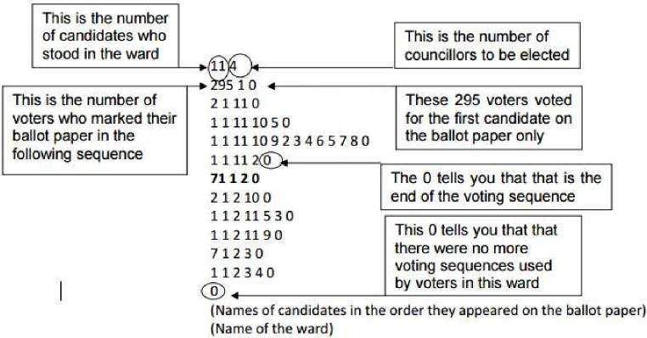
If you have any questions about the reports, please contact the Elections Office on 01835 826556

